

 Victoria Early Learning and Childcare

Victoria Early Learning and Childcare is located within the Newhaven area of Edinburgh. Victoria ELC opened on 25th April 2022 within an established school that had not previously offered early learning and childcare.

The ELC offers 120 places of 1140 hours to children between the age of 2 years and 5 years during the hours of 8am and 6pm and throughout the full year. The models of delivery are term time, AM, PM and two full days with a flexi Friday included.

Victoria Early Learning and childcare staff team
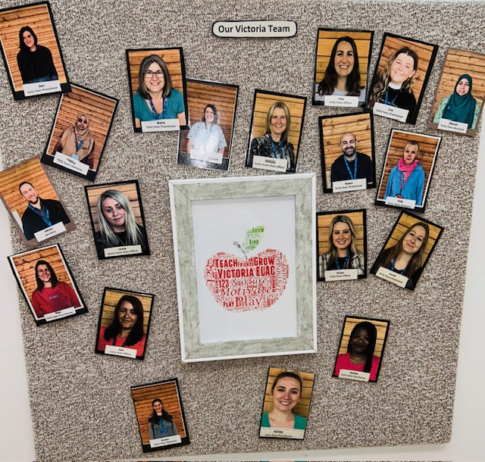

Senior Early Years Officers, Michelle and Louise
Early Years Officers, Kairen, Jade and Lucy
Early Years Practitioners, Ashley, Deri, Erin, Ruben, Marta, Bego and Leonie
Early Years Assistants, Lucinda, Tara and Marfua
Early Years Domestics, Fatima and Annetta
Clerical, Johnny

Well-being Policy
Victoria Primary Early Learning and Childcare

At Victoria Early Learning and Childcare, we aim to provide a warm, welcoming environment with an ethos that helps all families to feel valued and included understanding that relationships are key to successful partnerships with families.
Quality transitions are well-prepared, and child centered working together to meet each child's individual needs. Including well considered settling arrangements being discussed and agreed with parent/carers as encountering new or different environments and routines can be stressful and we understand parents and carers know and understand their child best.
- Parents can expect to stay and help settle their child into their new environment.
- Effective two-way communication with parents/carers phone calls, email, message, learning journals
- Flexible routines and structures also for siblings to spend time together
- To use transitional objects, a favourite cuddly toy, blanket
Our skillful practitioners will support individual children to become confident, secure and comfortable as they settle into and find their place within the rhythm of the playroom. Establishing positive, loving, nurturing and understanding relationships promotes in children a sense of belonging. Positive relationships with parents and carers valuing their contribution, complexities, diversities and cultural differences of individual families with respect, understanding and empathy to ensure our relationships are built on trust.

At times families can be met with challenges and settings can be a powerful place for children and families to experience positive relationships, social inclusion and to be signposted to sources of help. Victoria Early Learning and Childcare will support the child’s social, emotional and mental well-being by engaging meaningfully with others including parents/ carers as equal partners.
A young child’s voice is interpreted by our observation of their actions, emotions and words. Young children are learning to self-regulate and it is important to remain calm, reflective and mindful in seeing things from the point of view of the child. As stated in the United Nations Rights of the Child Article 12, says “I have the right to be listened to and be taken seriously”. Establishing positive, loving, nurturing and understanding relationships. Building an environment of relationships, security of space and a sense of being loved and cherished that children need from us in order to feel safe and cared for.

This Policy is informed by Education Scotland, Realising the Ambition, 2020.
If you have any questions regarding this policy, please speak to a member of staff.

Reviewed September 2024

Food and Nutrition Policy

At Victoria Early Learning and Childcare, we promote healthy foods and nutrition and will provide opportunities for children to experience new tastes, develop social skills and enjoy healthy options.

This policy aims to ensure a consistent approach to promote healthy attitudes towards food through our provision of food, drink and the encouragement of the social aspect of eating together. We will use Setting the Table (2015) guidance and Food Matters when planning our approach to food, including menus for all meals, snacks and drinks.

Our aim.
- Promote healthy attitudes towards our provision of foods, drink and the encouragement of the social aspect of eating together.
- Children will be offered a variety of healthy foods throughout the day with access to fresh drinking water.
- Children will be consulted and listened to in making snack choices.
- Children will be involved in food preparation.
- Children will be involved in setting up for lunch time.
- We have introduced a self-serve, rolling lunch to provide children with independence skills and the freedom to make choices.

Lunchtime meals will be provided by Oakland Primary School kitchen.
Menu plans will be displayed for families in advance.

To achieve this:
- Provide high quality experiences, supporting children to learn about healthy choices.
- Provide a nurturing environment where children experience a variety of different food types.
- Respect children’s individuality and respond to their needs appropriately.

Parents and carers:
- Provide updated details of special dietary requirements/food allergies.
- Parents can gain more knowledge with regard to food and nutrition.
- Collaboration with children and families regarding menus.

Children:
- Children will be offered a variety of healthy snack options throughout the day.
- Meals and snacks will meet cultural and dietary needs, beliefs and preferences
- Children will be involved in the handling and preparing of food.
- If children need help with eating and drinking, this is carried out in a dignified way and all personal preferences are respected.
- Children can choose to make a variety of foods and snacks, with support if needed, and can choose to grow, cook and eat my own food.

. Links to support:
http://www.healthscotland.com/uploads/documents/30341-Setting%20the%20Table.pdf
https://www.careinspectorate.com/index.php/low-graphics/76-publications/professionals-registration/resources/4705-food-matters-nurturing-happy-healthy-children
For further information regarding our food and nutrition policy, please speak to a member of staff who would be happy to help.

Victoria Early Learning and Childcare
Updated: October 2024.

The early experiences children have of food and mealtimes play an important part in shaping later eating habits. We have developed the opportunity for children to be involved in a self-serve lunch routine. Our aim is to achieve a relaxing and sociable experience for all children. This will benefit children's emotional wellbeing and encourage independence and promote healthy attitudes toward our provision of food and drink and the encouragement of the social aspect of eating together.

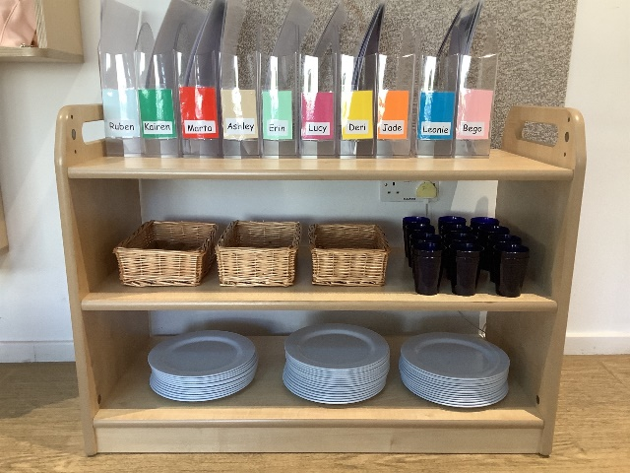
Children’s comments....
“I like to make my own foods”
“I like that I can choose my own foods and put it on my plate”
“This is not noisy; I like it quiet I can talk to my friends”
